**Assignment-1**

**Ordering in Group Communication**

Shikher chhawchharia- CS21M014

Abhishek Srivastav-CS21M001

1. Causal ordering:

Assumptions: exactly three nodes in the p2p network, all working at the same port. There will not be more than 10 messages sent at a time to a single node.

We present two examples to demonstrate causal ordering

Example 1:

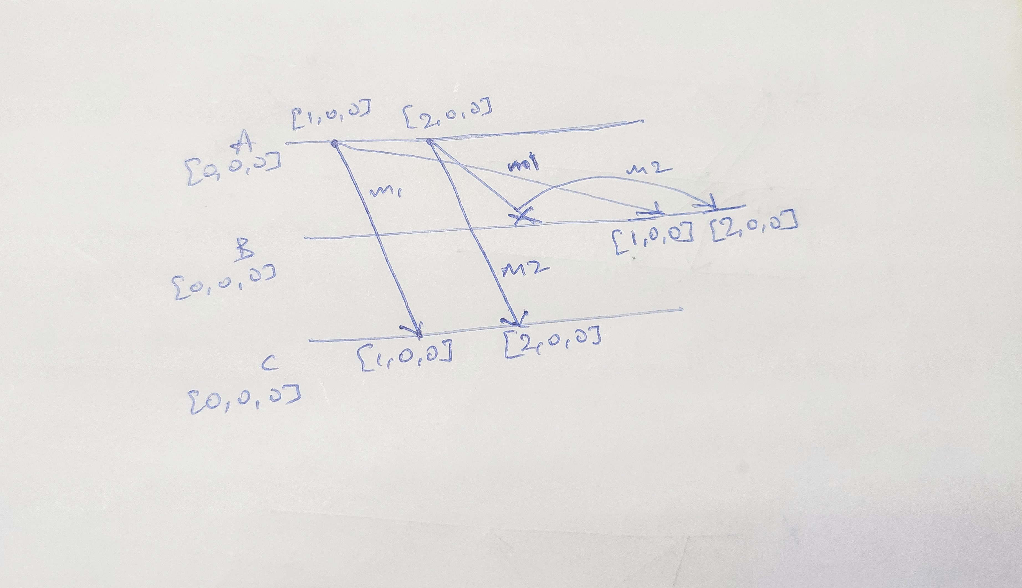

* A sends a two messages to B and C, one after the other. C receives the first message first and delivers it.

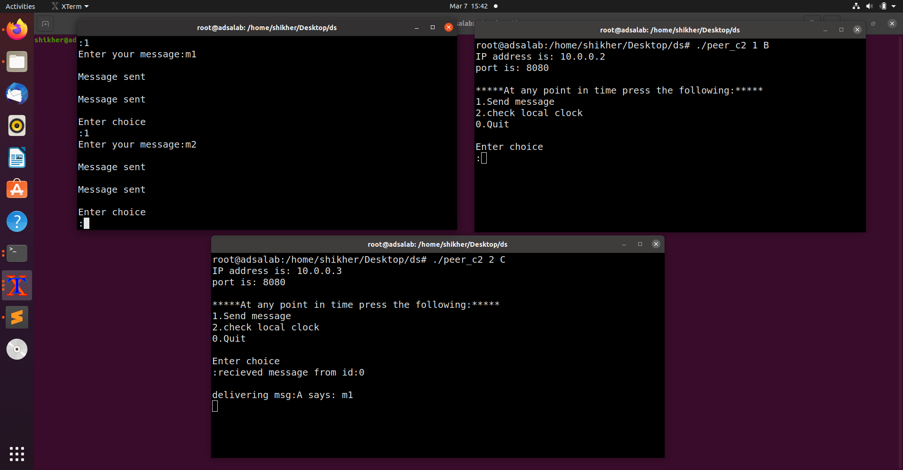

* B receives the second message first , so puts it in buffer. At the same time C receives the second message and delivers it. Then B receives the first message , and delivers it and finally picks the second message from the waiting queue and delivers it

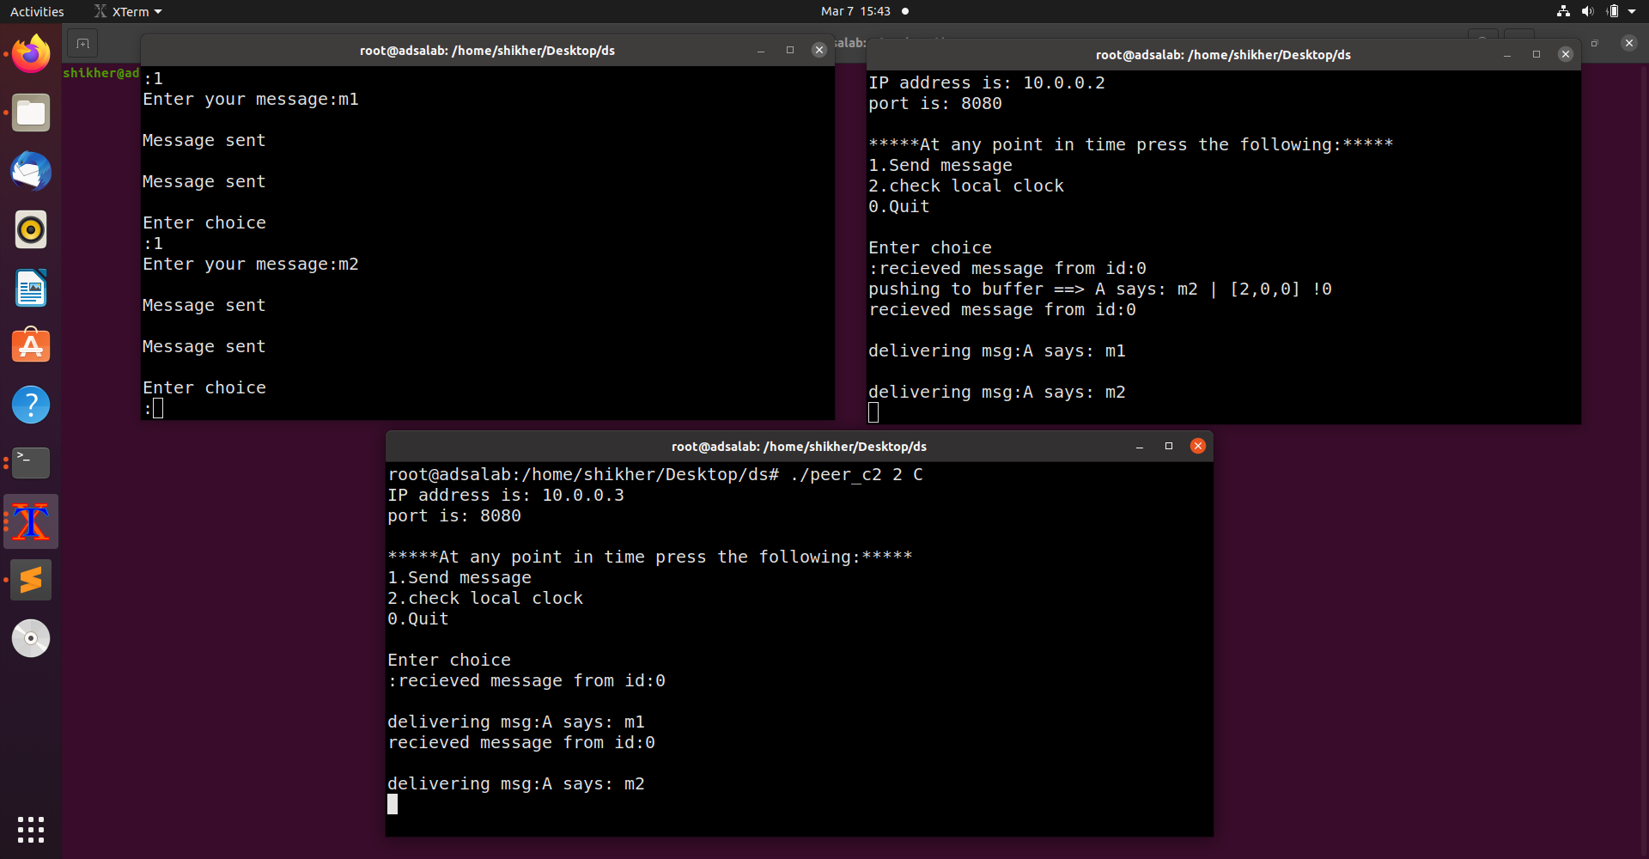

Example 2:

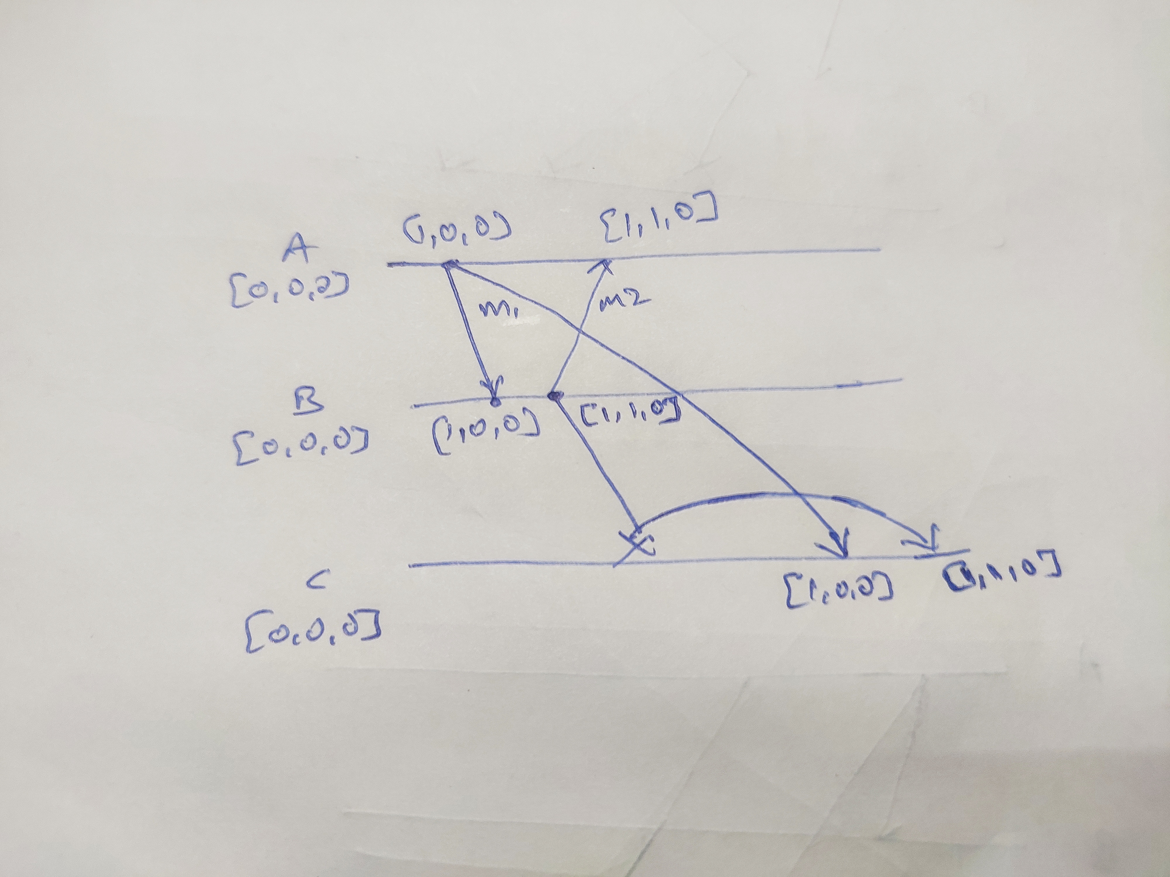

* A sends a message to B and C. B receives the message and delivers it. C hasn’t received it yet. Then B sends a message to A and C. A receives the message and delivers it. C also receives the message from B, but since it has causal dependency to the one from A, it pushes the message to buffer.

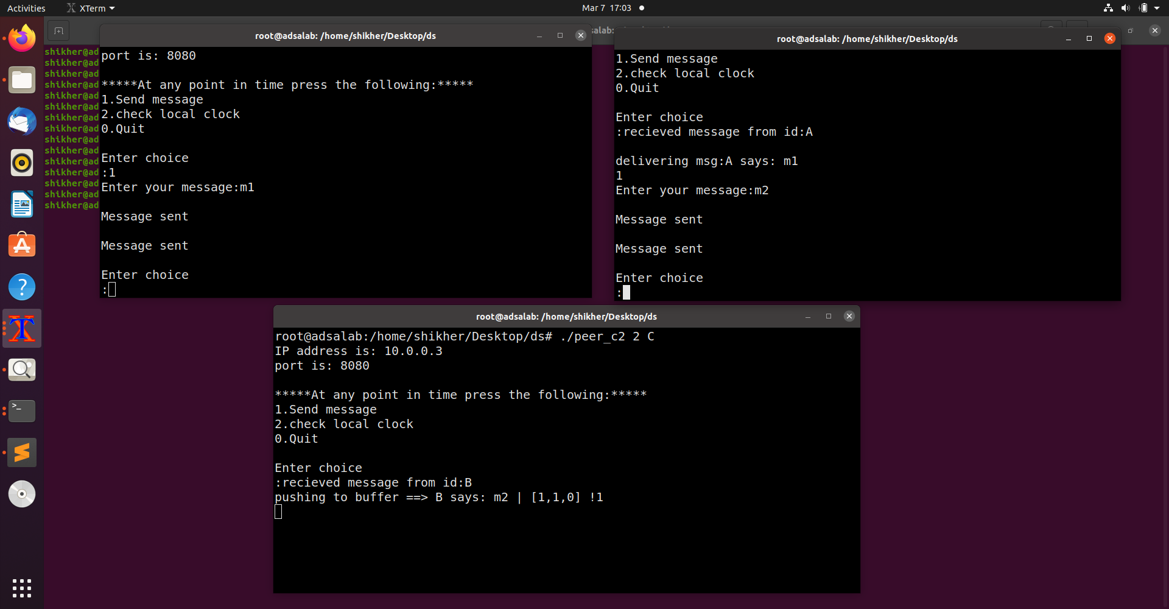

* C receives the message from A and delivers it. Then picks the message from B, which was waiting in the queue , and delivers it.

